Amazon E-Commerce Supply Chain Insights Through SQL and Python Visualization

1. Introduction

The network that Amazon has is one of the most complex and largest in the world, and the data-based decisions play a vital role in maintaining efficiency and customer satisfaction and operational excellence in the company. With online retailing gaining speed, there has been a critical necessity to examine the supply chain performance on the basis of real-time information to improve logistics, delivery performance, warehouse management, and demand prediction within the organization. The project is designed to reproduce an actual supply chain analytics process in Python and MySQL to process operational data of different sources, such as orders, customer feedback, warehouse management, transportation indicators, and seasonal demand trends.
In this project, a full relational database was developed, built, and filled with more than 100,000+ data in various datasets that reflect the key elements of Amazon supply chain. The database contains rich data on customer orders, warehouse processing activities, performance of the courier, customer satisfaction ratings and seasonal demand indicators. Data were extracted, cleaned, and aggregated with the help of SQL query whereas Python was utilized as the analytical engine to visualize performance metrics that are important. This SQL/Python gives a robust end-to-end analytics pipeline that represents industry-best practices in Business Analytics and Supply Chain Management.
The discussion is aimed at establishing bottlenecks, workforce discrepancies, courier delays, customer sentimentation trends, staffing uncorrelations, and seasonal demand variations. A total of seven key visualizations were created using Matplotlib and Pandas in Python and each one provided important information about the performance of the supply chain. These are courier performance and average delay, average delay across cities and warehouses, customer rating in relation to delivery time, workforce and volume of order in relation to warehouse, courier on time delivery and correlation between seasonal change of demand with actual order volume.
Finally, this project indicates how data analytics can be applied to learn and enhance supply chain performance. The resulting insights can assist the companies to make wise judgments when assigning resources, planning their workforce, choosing couriers, courier customer experience planning, and optimization of their inventory. This analytical method, when paired with SQL-based data engineering and Python-based visualization and interpretation, demonstrates the importance of the combination of these two fields in the context of a competitive e-commerce environment where the speed of delivery, consistency, and customer satisfaction are paramount factors when it comes to spurring continuous improvement.

2. Goals

- The main goals of this project include:

- To explore the Amazon supply chain data with the help of SQL and Python to make informed decisions.

- To determine the bottlenecks of the delivery performance in the cities, couriers and warehouses.

- The purpose of the study is to determine the effect of seasonal variation in demand on the quantity of orders.

- To measure the efficiency of the workforce and distribution of workload in the warehouse.

- To explore the hypothesis of the dependency of customer ratings on the delays of their delivery.

- In order to represent operational performance through bar charts, line charts, dual axis charts and time series plots.

- To create ideas that can be used to enhance the speed, reliability, and customer satisfaction of the supply chain.

3. Methodology
The methodology that is applied in this project is structured based on real-life analytics processes that are applied in supply chain and logistics companies. It starts with data preparation and database creation, followed by SQL-based data extraction and ends with the analysis and visualization carried out using Python. The step-by-step research procedure guarantees precision, repeatability, and intelligibility of the research procedure.
Step 1: DB Creation and DB Development.
MySQL was used to import all raw CSV files and create a structured relational database called amazon supply chain. To enforce referential integrity and to define relationships among tables, primary keys and foreign keys were developed to connect orders to warehouse operations, seasonal demand to transportation data and customer reviews and warehouse master data. The types of data were properly allocated in order to make correct calculations and optimization of performance.
Step 2: SQL-based Data Mining and Aggregation.
The SQL queries were run to retrieve the important metrics and the aggregate operations like the average delivery delay, the number of orders made in each warehouse, the percentage of on-time delivery, the changes in demand by season and customer rating analysis. Delays metrics and the creation of meaningful cross-table summaries were calculated using complex JOINs, GROUP BY and date functions like DATEDIFF. SQL views were designed to improve the calculation of the same information and standardization of the workflow.

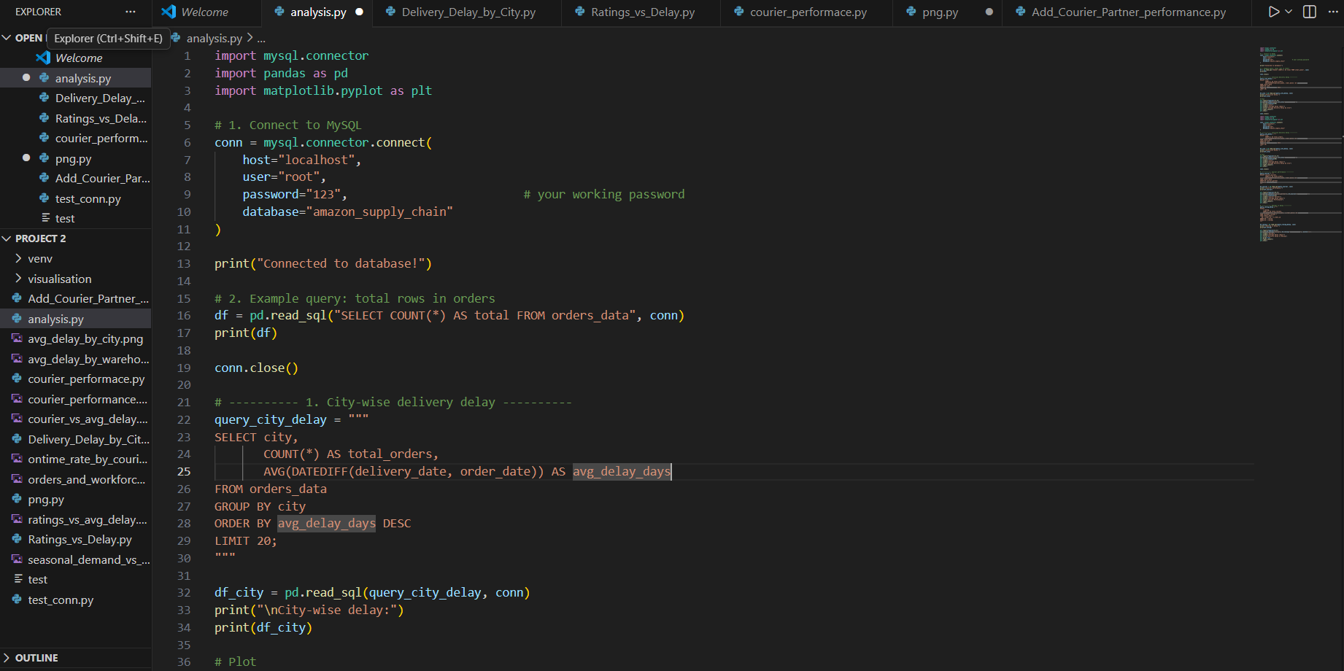

Step 3: Python-MySQL The mysql.connector interface.
Python was linked to MySQL database through mysql. connector library where SQL queries can be compiled directly into python scripts. The results of the query were loaded into Pandas DataFrames and allowed operating with data flexibly and perform analytical operations. It was also enabled by this integration to provide a faster iteration in analysis.
Step 4: Pandas and Matplotlib Visualization.
Python was used to create seven major visualizations, which included courier performance, delays at city level, warehouse efficiency, demand trends by season, workforce distribution, and customer rating. Quantitative measures were represented in bar charts, line charts and dual axis charts in a clear and effective way. PNG data were stored to be reported.

Step 5: Insight Extraction and Interpretation.
Every visualization was examined to be able to find the patterns, inefficiencies, demand variability, and performance bottlenecks. Systematic recording of interpretations was done.

4. Findings / Results
The paper has produced seven significant insights as a result of SQL queries and Python visualizations. All outcomes offer a different supplier chain performance point of view.
1. Courier vs Average Delay of Delivery.
Orders were delivered by all couriers in a very similar time frame (~3.2 3.3 days). This is an indication that there are no major courier-based delay problems. Internal processes, logistics of the warehouse or specifics of the city are therefore more likely to be associated with operational delays.
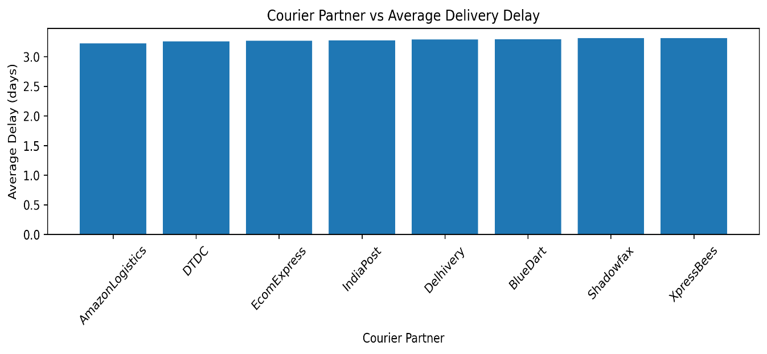

2. Average Delay by City
There was also consistency in delivery delays within the cities with low variance. There were slightly more delays in a few cities, which could be explained by traffic jams, inefficiency of last-mile delivery, or local logistics.
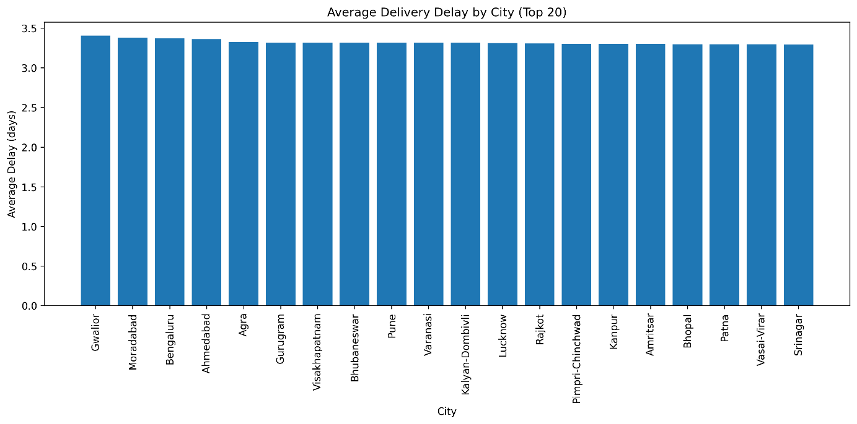
4. Ratings vs Delivery Delay
There was no significant change in customer rating over changes in the delay in delivery. Ratings did not change even with +0.1 or -0.1 days variations. This means that customers are more concerned with the quality of products, packaging, and communication, coupled with returns processes as opposed to minor changes in delivery speed
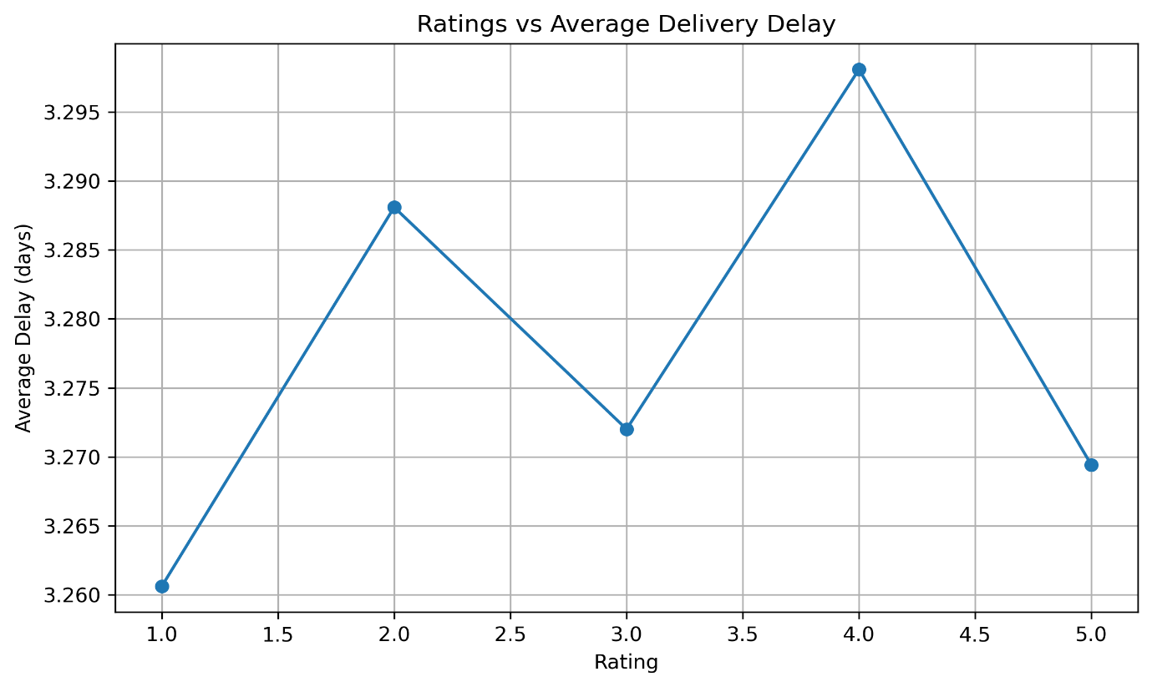.
3. Average Delay by Warehouse
There were also some warehouses with more delays and most of them were caused by workforce mismatch or inefficiency in processing. The situation of warehouses with bigger quantities of orders and a lack of workforce relative to performance was apt to be slower, which indicated imbalance of operations.
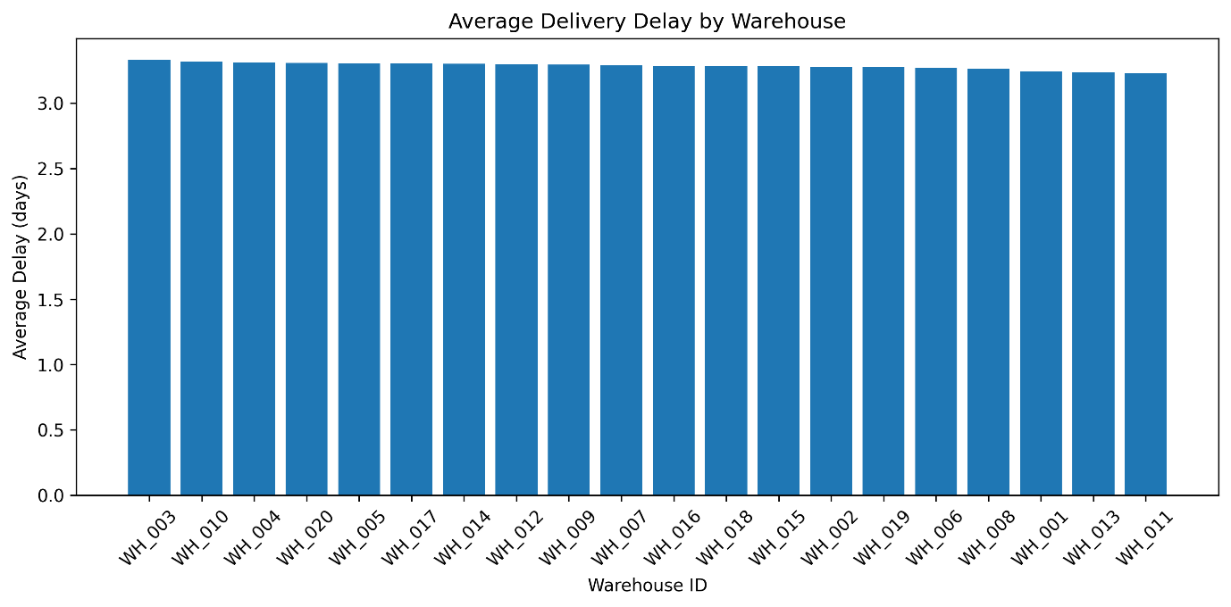
5. Orders + Workforce (Dual Axis)
Higher workforce was being managed more effectively in warehouses with higher volumes of orders. On the other hand, smaller warehouses that employed few workers did not perform well even when there was a lot of workload. This disparity is an indication of a problem in resource distribution.
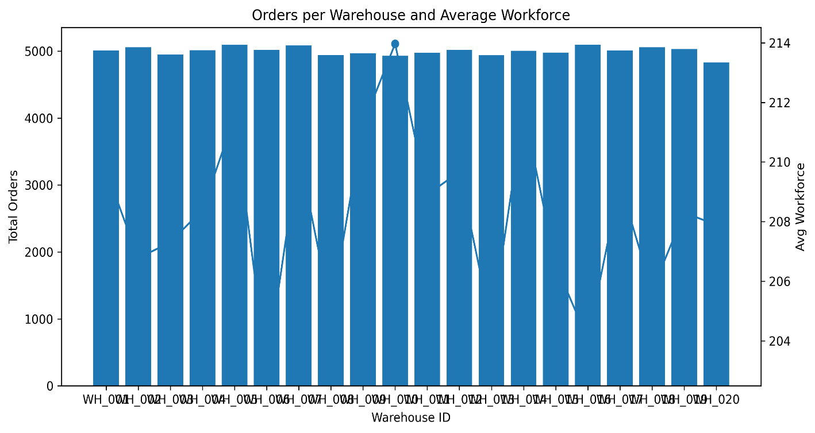
6. Courier On-Time Rate
There were minor variations between the performance of some couriers in giving delivery on time. Customers have the ability to be satisfied by the performance of the courier which was competent.
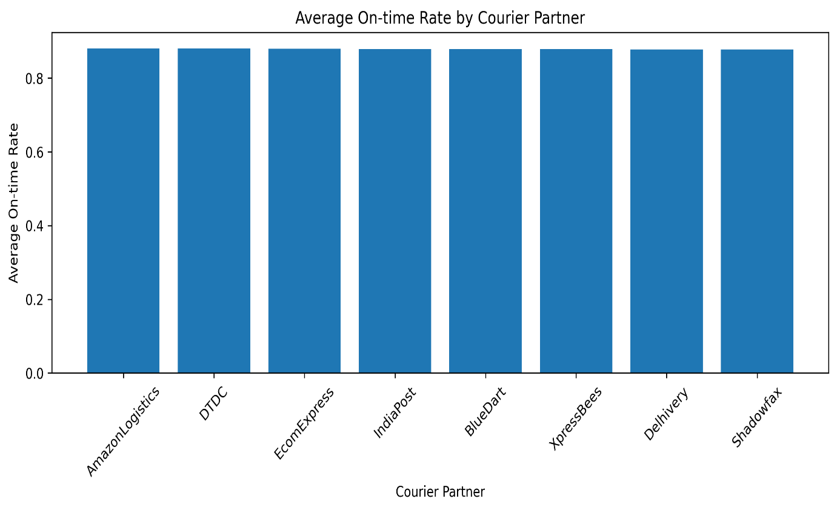
7. Demand by the season vs Actual Orders.
It was found that the demand patterns were consistent with the real order volumes particularly during seasons, festivals or promotion events. This is predictable seasonality, which may be used to plan.

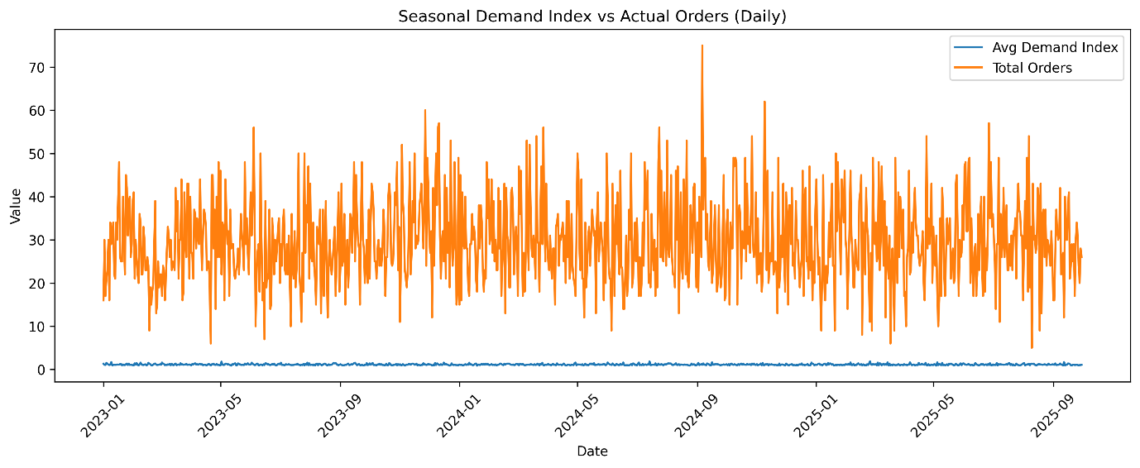

5. Conclusion

This project has managed to show the strength of combining SQL and Python to use in supply chain analytics. The project recreates workflows employed by industries in analytics teams of e-commerce organizations, including Amazon, Flipkart, Walmart, and other companies, and can be used to create a relational database and execute SQL queries in Python. The thorough data mining, visualization, and analysis revealed the major findings in the form of the warehouse efficiency, the performance consistency of couriers, the demand trends by seasons, and customer satisfaction patterns.

The results indicate that the level of performance of courier partners is quite similar, indicating that those factors related to the inside operation are the most important factors in delays as compared to those related to the outside logistics partners. There is relative stability in the delivery performance, and the variance is minor, which implies that the Amazon last-mile infrastructure is not very weak in most cities of the country. The efficiency of warehouses is important in accelerating deliveries as the one with a higher number of workforce is the most efficient. Seasonal demand forecasting proved to be an essential factor with great conformity to the real order volume pattern.

All in all, it can be said that the combined application of SQL and Python illustrates how organizations may make informed decision making by analysis of operational data. The lessons learned during this undertaking will contribute to efficient allocation of workforce, better warehouse processing time, the choice of trustworthy courier, and seasonal peak preparation. This is an efficient end-to-end analytical tool that can be viewed as a good illustration of a data-driven supply chain optimization.

